Evaluating the Lamba Compute Model  
CS 470 Full Stack Development II

Sergio Mateos

Southern New Hampshire University

Part One: Creating and Testing Lamaba

1. Graphical user interface, application, website

   Description automatically generatedAWS Lamba
2. 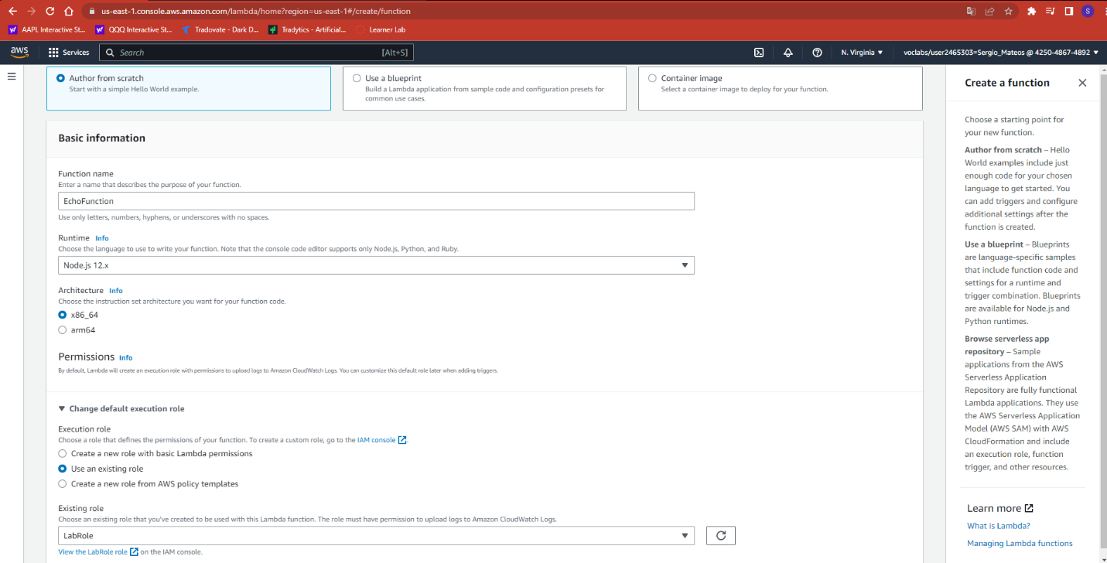Creating a Lamba
3. Graphical user interface, application

   Description automatically generatedLamba Created
4. Graphical user interface, text, application

   Description automatically generatedTest
5. Graphical user interface, text, application

   Description automatically generatedExecuting Results

Part Two: Creating an Echo Function

1. Graphical user interface, application

   Description automatically generatedFirst serverless compute function
2. A screenshot of a computer

   Description automatically generatedEchoWithQuery execution results
3. Graphical user interface, application

   Description automatically generatedChange on index.js
4. Graphical user interface, application

   Description automatically generatedDeploy and Test

Part Three: Enhancing the Echo Function

1. 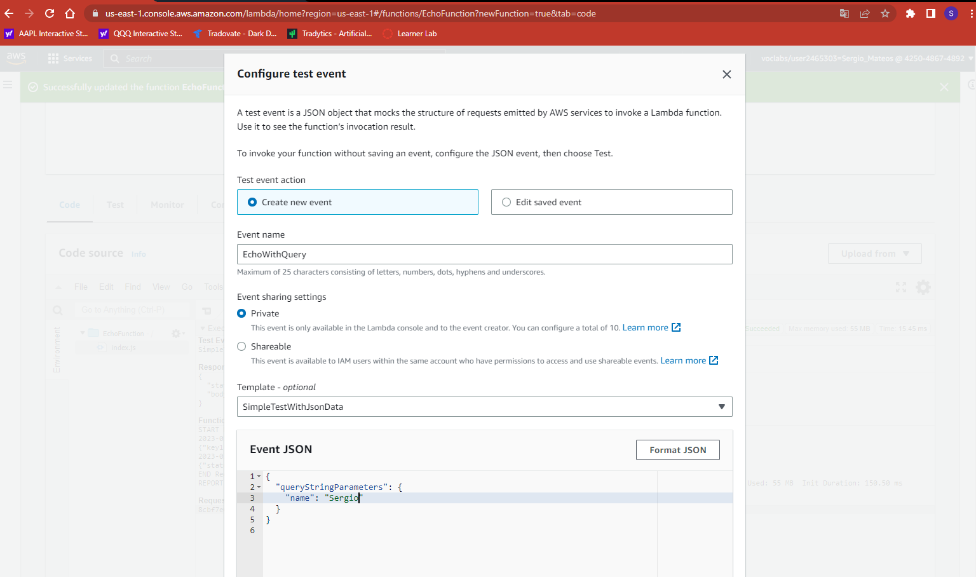JSON for the created test event
2. Graphical user interface, text, application

   Description automatically generatedIndex.js
3. EchoWithQuery

